

Assignment 1

CSCI 2304

INTELLIGENT SYSTEMS

Section 1

Name: MOHAMED MOUBARAK MOHAMED MISBAHOU MKOUBOI

Matric No: 1820705

Lecturer

Dr. SURIANI BT. SULAIMAN

# ASSIGNMENT 1: STATE SPACE SEARCH (PAIR) SECTION 1

**ASSIGNED DATE: 22 MARCH 2021**

**DUE DATE: 4 APRIL 2021**

1. Figure 1 depicts the graphic representation of the highways interconnecting 8 cities {Newton; Dover; Ridgewood; Madison; Hackensack; Somerville; Washington; Columbia; i} in the state of New Jersey, United States. The actual distance of the highway connecting two cities is given in miles. For example, the highway for {Newton; Dover} is 22 miles in its actual distance.

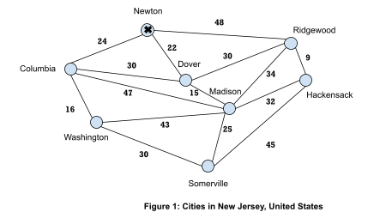

1. Write down 2 (two) possible paths that travel to all cities in which each city is visited exactly once and return to the initial starting city marked in the diagram. (3 marks).

* Path 1: Newton, Ridgewood, Hackenson, Somerville, Madison, Washington, Columbia, Dover, Newton
* Path 2: Newton, Ridgewood, Dover, Madison, Hackensack, Somerville, Washington, Columbia, Newton

1. Construct the 2 (two) trees generated based on your algorithms in (a) (5 marks).

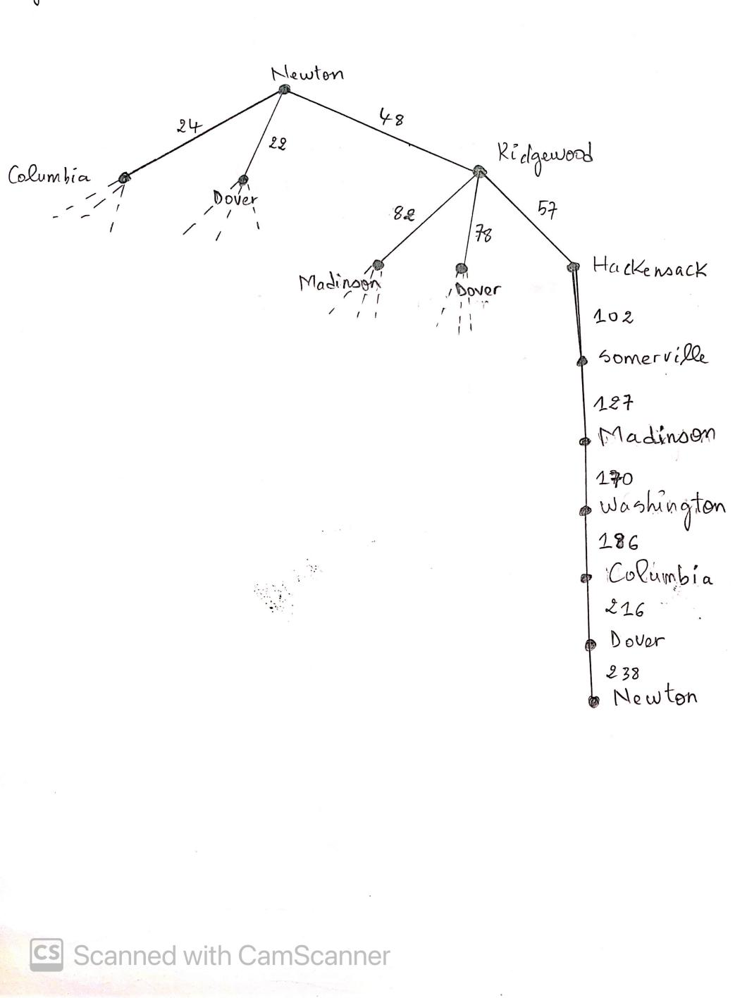

Path 1: Newton, Ridgewood, Hackenson, Somerville, Madison, Washington, Columbia, Dover, Newton

Cost : 238

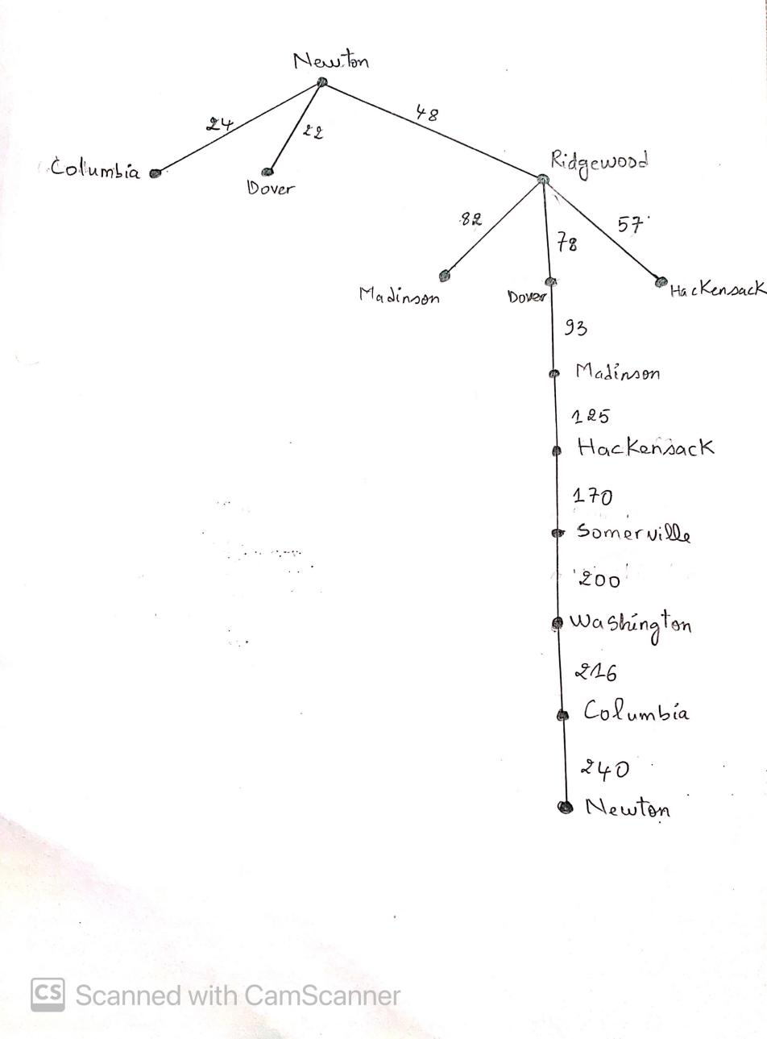

Path 2: Newton, Ridgewood, Dover, Madison, Hackensack, Somerville, Washington, Columbia, Newton

Cost : 240

1. Using the *nearest neighbor* and *minimal cost* algorithms, determine the search algorithm that gives a lower total distance travelled by calculating its cost (4 marks).

**Nearest neighbor :**

Newton, Dover, Madison, Ridgewood, Hackensack, Somerville, Washington, Columbia, Newton

Total cost = 22 + 15 + 34 + 9 + 45 + 30 + 16 + 24 = **195**

**Minimal Cost algorithms :**

Newton, Columbia, Washington, Somerville, Madison, Hackensack, Ridgewood, Dover, Newton

Total cost = 24 + 16 + 30 + 25 + 32 + 9 + 30 + 22 = **188**

1. Based on the graph in Figure 1 and sample Python codes given, modify the Python program that solves problem (1) returning the minimal path (4 marks).

Adjency Matrix :

|  |  |  |  |  |  |  |  |  |
| --- | --- | --- | --- | --- | --- | --- | --- | --- |
|  | N | C | W | S | H | R | D | M |
| N | 0 | 24 | 0 | 0 | 0 | 48 | 22 | 0 |
| C | 24 | 0 | 16 | 0 | 0 | 0 | 30 | 47 |
| W | 0 | 16 | 0 | 30 | 0 | 0 | 0 | 43 |
| S | 0 | 0 | 30 | 0 | 45 | 0 | 0 | 25 |
| H | 0 | 0 | 0 | 45 | 0 | 9 | 0 | 32 |
| R | 48 | 0 | 0 | 0 | 9 | 0 | 30 | 34 |
| D | 22 | 30 | 0 | 0 | 0 | 30 | 0 | 15 |
| M | 0 | 47 | 43 | 25 | 32 | 34 | 15 | 0 |

 



1. Solve the 8-puzzle problem given below using the A* search function *f(n) = h(n) + g(n)*. Show your steps clearly. Solve the problem partially only until the third ply/level of the tree. The initial and goal state are given to you (4 marks).

|  |  |  |
| --- | --- | --- |
| 7 | 4 | 1 |
| 3 |  | 5 |
| 6 | 2 | 8 |

|  |  |  |
| --- | --- | --- |
| 4 | 8 | 1 |
| 3 | 7 | 6 |
|  | 5 | 2 |

Initial State Goal State

|  |  |  |
| --- | --- | --- |
| 7 | 4 | 1 |
| 3 |  | 5 |
| 6 | 2 | 8 |

|  |  |  |
| --- | --- | --- |
| 7 |  | 1 |
| 3 | 4 | 5 |
| 6 | 2 | 8 |

|  |  |  |
| --- | --- | --- |
| 7 | 4 | 1 |
| 3 | 2 | 5 |
| 6 |  | 8 |

|  |  |  |
| --- | --- | --- |
| 7 | 4 | 1 |
| 3 | 5 |  |
| 6 | 2 | 8 |

|  |  |  |
| --- | --- | --- |
| 7 | 4 | 1 |
|  | 3 | 5 |
| 6 | 2 | 8 |

g(n)=1, h(n)=6

f(n)=1+6=7

g(n)=1, h(n)=6

f(n)=1+6=7

g(n)=1, h(n)=7

f(n)=1+7=8

g(n)=1, h(n)=6

f(n)=1+6=7

|  |  |  |
| --- | --- | --- |
| 7 | 1 |  |
| 3 | 4 | 5 |
| 6 | 2 | 8 |

|  |  |  |
| --- | --- | --- |
|  | 7 | 1 |
| 3 | 4 | 5 |
| 6 | 2 | 8  g(n)=2, h(n)=8  f(n)=2+8=10 |

|  |  |  |
| --- | --- | --- |
| 7 | 4 | 1 |
| 6 | 3 | 5 |
|  | 2 | 8  g(n)=2, h(n)=7  f(n)=2+7=9 |

|  |  |  |
| --- | --- | --- |
|  | 4 | 1 |
| 7 | 3 | 5 |
| 6 | 2 | 8 |

|  |  |  |
| --- | --- | --- |
| 7 | 4 | 1 |
| 3 | 2 | 5 |
|  | 6 | 8 |

|  |  |  |
| --- | --- | --- |
| 7 | 4 | 1 |
| 3 | 2 | 5 |
| 6 | 8 |  |

|  |  |  |
| --- | --- | --- |
| 7 | 4 |  |
| 3 | 5 | 1 |
| 6 | 2 | 8 |

|  |  |  |
| --- | --- | --- |
| 7 | 4 | 1 |
| 3 | 5 | 8 |
| 6 | 2 |  |

g(n)=2, h(n)=6

f(n)=2+6=8

g(n)=2, h(n)=7

f(n)=2+7=9

g(n)=2, h(n)=6

f(n)=2+6=8

g(n)=2, h(n)=6

f(n)=2+6=8

g(n)=2, h(n)=6

f(n)=2+6=8

g(n)=2, h(n)=7

f(n)=2+7=9

|  |  |  |
| --- | --- | --- |
| 7 | 1 | 5 |
| 3 | 4 |  |
| 6 | 2 | 8 |

|  |  |  |
| --- | --- | --- |
| 3 | 7 | 1 |
|  | 4 | 5 |
| 6 | 2 | 8 |

|  |  |  |
| --- | --- | --- |
| 7 | 4 | 1 |
| 6 | 3 | 5 |
| 2 |  | 8 |

|  |  |  |
| --- | --- | --- |
| 4 |  | 1 |
| 7 | 3 | 5 |
| 6 | 2 | 8 |

|  |  |  |
| --- | --- | --- |
| 7 | 4 | 1 |
|  | 2 | 5 |
| 3 | 6 | 8 |

|  |  |  |
| --- | --- | --- |
| 7 | 4 | 1 |
| 3 | 2 |  |
| 6  g(n)=3, h(n)=6  f(n)=3+6=9 | 8 | 5 |

|  |  |  |
| --- | --- | --- |
| 7 |  | 4 |
| 3 | 5 | 1 |
| 6 | 2 | 8 |

|  |  |  |
| --- | --- | --- |
| 7 | 4 | 1 |
| 3 | 5 | 8 |
| 6 |  | 2 |

g(n)=3, h(n)=6

f(n)=3+6=9

g(n)=3, h(n)=7

f(n)=3+7=10

g(n)=3, h(n)=7

f(n)=3+7=10

g(n)=3, h(n)=6

f(n)=3+6=9

g(n)=3, h(n)=7

f(n)=3+7=10

g(n)=3, h(n)=7

f(n)=3+7=10

g(n)=3, h(n)=7

f(n)=3+7=10

1. Describe your own ***real world problem*** that can be represented and solved using state space. Your problem must not be any of those already discussed in class (i.e., no points given for similar problems). Specify your states (including initial and goal) and operators (5 marks).

The real wold problem that we are going to discuss is “Online Transaction” and we have the initial problem, then the operation of that problem, and lastly the goal.

* **Initial :** Pre-purchase/sale which is focused on product ads and details.

1. **Registration:** For online purchases, it is needed. The individual who wishes to conduct an online purchase must first register with the online provider by completing a registration form. A ‘password' for the reported ‘account' and ‘shopping cart' is one of the many information to be filled in. Account and Shopping Cart are password protected for confidentiality purposes.
2. **Placing an order:** The items in the shopping cart can be added and removed by the online shopper. When visiting the online store, the shopping cart keeps track of what items have been selected. After ensuring that the products to be bought are correct, the shopper may choose a payment method.

* **Operation:** Purchase/sale which includes price of the product, price negotiation, actual purchase or sale and payment.

Payments may be rendered in a range of forms, including:

1. **Cash on delivery (CoD):** Payments for internet goods purchased are made following actual distribution of goods.
2. **Cheque:** The Seller receives the customer's check, and the items are shipped after the check is cleared.
3. **Net Banking Transfer:** Payment is made online, via the internet, from the buyer's account to the eseller's account. The seller dispatched the goods to the buyer after receiving payment from the buyer.
4. **Credit or Debit Cards:** The buyer's credit/debit card is used to make the purchase. To make a purchase, the buyer must exchange the details of his credit/debit card with the payment gateway; after the payment is processed by the vendor, the seller ships the items to the buyer. Plastic money is another term for credit and debit cards.
5. **Digital Cash:** It's a form of electronic money that only occurs in cyberspace. It doesn't have any tangible properties, so it helps you to spend real money in an electronic format. Knowledge is very relevant in all transactions. In both conventional and online (internet) industry, information is shared. However, as opposed to conventional business transfers, internet transactions are simpler. Traditional business requires time to drive, discuss (talk), persuade, and have both sides present for face-to-face conversation. A lot of time was lost in this process. As a result, online sales are more convenient and efficient than conventional industry.

* **Goal:** Delivery stage which after completing sale-purchase stage, this is the final stage.